 Pegasys
[Credit Card- Generate Monthly Transactions Reports]

- Monthly CRCD transactions — lists all transactions for a selected credit card statement period by Credit Card Alias and can be utilized by an Approving Official as approval of a cardholder’s credit card purchases that have been logged and reconciled in Pegasys. If a charge has been reconciled in Pegasys, the report also displays all applicable reconciliation information.

Figure 1
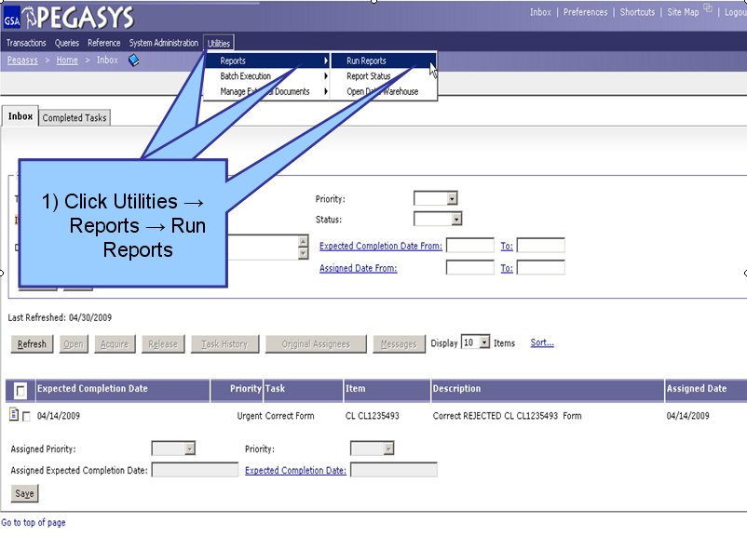
Figure 1

- From the Pegasys homepage, click on Utilities on the Menu Bar
- Click on Reports.
- Click on Run Reports.

**View Reports page is displayed for all available reports**

Figure 2
Figure 2

- Click the “+” box next to the Credit Card folder to expand this folder. (Step 1)
- Click the “+” box next to the Reports folder to expand this folder. (Step 2)
- Click on Monthly CRCD Transactions L once to highlight this report. (Step 3)
- Click the Select Report button after the report is highlighted. (Step 4)
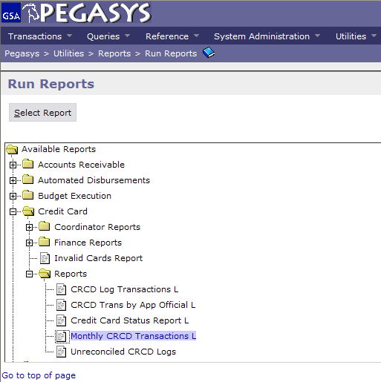
4) Click Select
Reports
1) Click Credit Card
2) Click Reports
3) Click Monthly CRCD Log Transaction L Transactions
(OVER)
Figure 3
Figure 3
- Enter in the Cardholder’s Alias. (Step 1)
- To narrow down the search parameters for your report, enter a specific Date Range. (Step 2)
- Click Run when finished. (Step 3)

**If the report has been generated, a message display will appear under the breadcrumbs track that says, “The report has been successfully submitted.”**
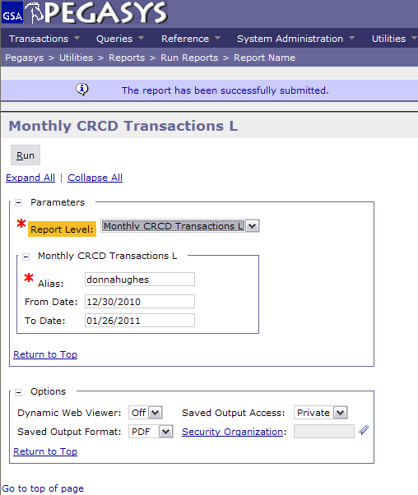
1) Type in Cardholder’s Alias
2) Enter Date Range
3) Click Run

Pegasys
[Credit Card- View Monthly Transactions Reports]

- Monthly CRCD transactions—lists all transactions for a selected credit card statement period by Credit Card Alias and can be utilized by an Approving Official as approval of a cardholder’s credit card purchases that have been logged and reconciled in Pegasys. If a charge has been reconciled in Pegasys, the report also displays all applicable reconciliation information.

Figure 1
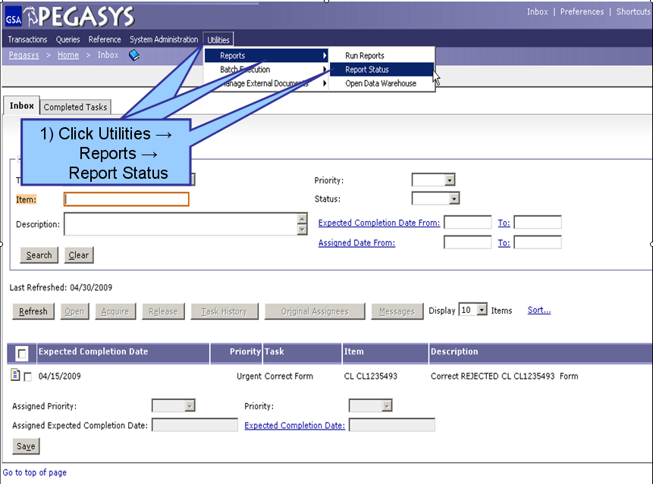
Figure 1

- From the Pegasys homepage, click on Utilities on the Menu Bar
- Click on Reports.
- Click on Report Status.

**Report Status Maintenance is displayed for all processing and/or completed reports**

Figure 2
Figure 2

- To find a report, the user can search by Report Subsystem. Enter all known information. (Step 1)
- Click Search. (Step 2)
- When the results are returned, select a report from the populated field. (Step 3)
- Click Details after the report is selected. (Step 4)
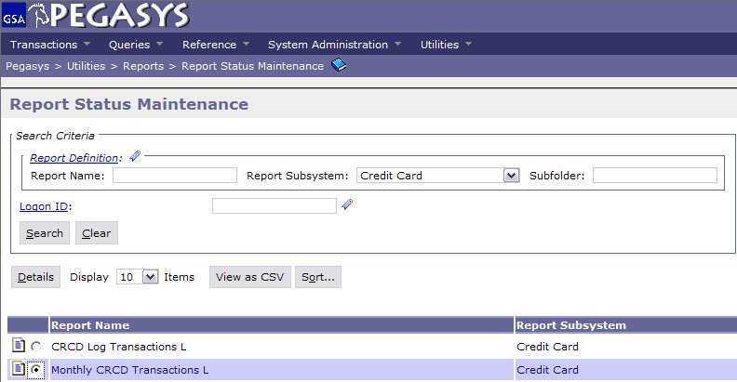
1) Search by:
Subsystem
2) Click Search
3) Select the Report
4) Click Details
(OVER)

Figure 3
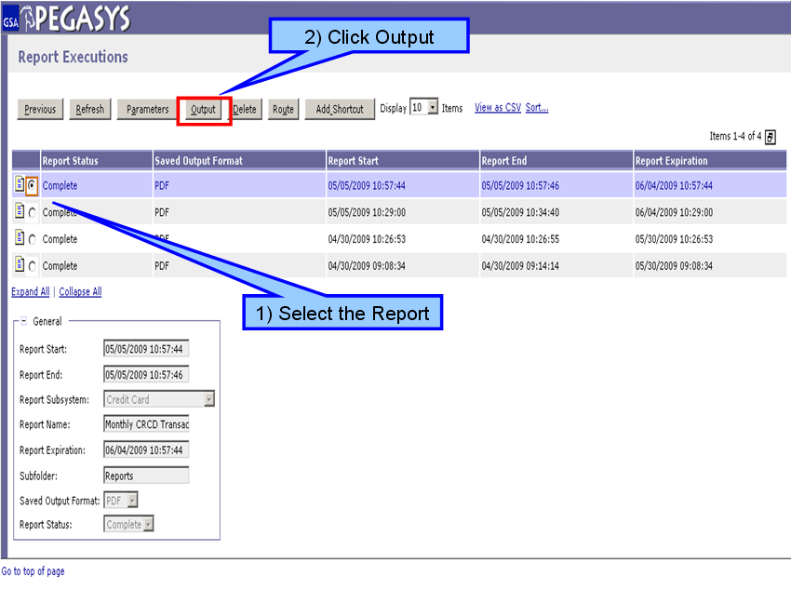
Figure 3

- On the Report Executions page, select the report to be viewed. (Step 1)
- Click Output after the report has been selected to view the report as a PDF file. (Step 2)

